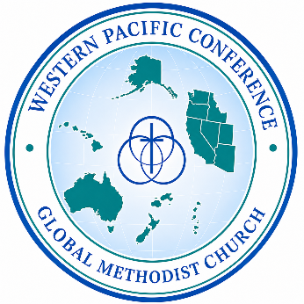
Charge Conference Report Form
For all churches in the Western Pacific Conference

___________________________ __________________________ ___________
CHURCH PASTOR(S) DATE
Use additional pages as necessary.
- Was this a ______ Charge Conference or a ______ Church Conference
- As of today, how many
  - Members __________
  - Inactive members __________
  - Average worship attendance __________
  - Number of services __________
  - Number of Bible Studies / Classes / Small Groups __________
By what criteria are members determined as active or inactive?
- What members are removed from the roles today by the vote of the charge conference?

- How many persons have joined the membership this year by:
  - Profession of faith __________
How many of these were youth from a Confirmation Class __________
  - By transfer of membership __________
  - By restoration __________
- How many persons have been removed from membership by
  - Withdrawal __________
  - Transfer __________
  - Removal __________
  - Death __________
- Who has been removed? (names)

- Are background checks done on all adults working with the children? YES NO
If you need assistance getting this setup, please indicate: YES NO
8. Who is recommended as a candidate for ministry by the charge conference this year?

- Who has been previously recommended? What is known of his/her present status?

- Who is recommended for certification as a lay minister this year?

- Who is recommended for renewal of their certification as a lay minister?

- How much is budgeted for connectional giving in the coming year?
To the GMC ___________ To the Western Pacific Conference ________

- How much is budgeted for missional giving in the coming year? __________________
Comments (Share about your mission focus.)

- Will this church commit to starting or supporting one or more new faith communities in the coming year? YES NO
Comments
15. Do you have a current insurance policy in place with the Western Pacific Conference listed as an additional insured? YES NO
16. Is the church incorporated in the state it resides and is its status “active”?
YES NO
17. Is there a bank account set up and being used and is it in the name of the church, not an individual? YES NO
18. Does the church have financial statements and are these available to the church body at the Charge Conference? YES NO

Other notes as necessary.
(If you are explaining an answer above, please reference the question number.)

