Clergy Compensation Report
For the year: _______________________________________________________________________
Name of Clergy: ____________________________________________________________________
Name of Charge: ___________________________________________________________________
District: ____________________________________________________________________________
The pastor is appointed (circle) Less than 1/4 1/4 1/2 3/4 Full time
Please see attached directions
Is a parsonage provided in lieu of any paid housing allowance? (circle) YES NO
Monthly Annual
Base Salary ________________ _______________
Housing Allowance ________________ _______________
Total Base + Housing __________________
Health Insurance Premium ________________ _______________
Life / Disability Insurance Premium ________________ _______________
Retirement ________________ _______________
Accountable Reimbursement (see directions) ________________ _______________
Travel ________________ _______________
Education ________________ _______________
Other ________________ _______________

Total Clergy Remuneration ________________ _______________
The above was approved on ____________________________________________ at a properly called Charge Conference.
__________________________________________
Charge Conference Secretary
Directions for completion of the Clergy Compensation Report

Appointment percent
This would have been established at the time of the appointment. If you are not sure, please contact your Presiding Elder.

Base Salary
This is the base pay the clergy member appointed to this church will be paid.
Housing Allowance
This is the amount the church will pay the clergy member for housing. This is above and beyond the Base Salary. The pastor should consult their tax advisor before working with the church on their housing allowance. This is regulated by the IRS and should be set only in conjunction with the pastor.
Tip: For church planning and budgeting, consider the total base salary + housing allowance you are able to / desire to pay your pastor. Have the pastor consult their tax advisor on how much of that total salary should be housing. Put that amount on the housing line.
NOTE: If you have a parsonage, mark the appropriate line on this form and list the rental value in the proper columns. Note clearly to the pastor that they are not paid for the housing allowance because a parsonage is provided. This must be made clear.

Salary Guidelines
Because of how vast the Western Pacific Conference is, it has not set a Conference Minimum for full-time salary. The Conference highly suggests each church enter into a time of prayerful discernment with their Presiding Elder about the salary of its pastor. Things to consider: local cost of living, status (1/4, 1/2, 3/4, or full time), expectations, pastoral experience, size of congregation, etc. This amount is set before the appointment is made, but a minimum of a COLA increase every year is appropriate.

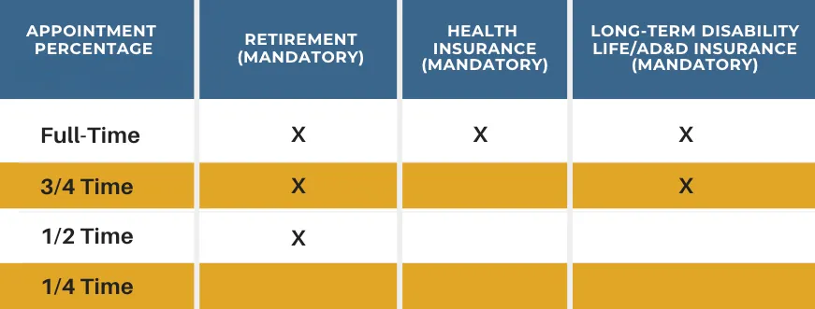
Clergy Benefits

Health Insurance
All full-time clergy shall participate in the Global Methodist Church/GuideStone group health insurance plan. However, clergy may waive participation by claiming one of the four allowable exceptions (see your Presiding Elder or www.GlobalMethodist.org)
The retirement (pension) plan works as follows:
- The church is required to make a base contribution of 5% of the pastor’s salary + housing into the pastor’s retirement account at GuideStone; PLUS
- The pastor is encouraged to make a personal contribution to their retirement account through a pre-tax salary-reduction arrangement with the local church; at least 5% is recommended, but the pastor is only limited by the IRS maximums. To see the amount for the following year, please visit www.GlobalMethodist.org or check with your Presiding Elder.
- The church is required to match the pastor’s personal contribution, up to 5%. The church cannot contribute more than 10%.
Long Term Disability, Life, and AD&D
Coverage is mandatory for all clergy appointed at ¾ time or more. This coverage cannot be waived. The church pays 100% of the premium for the basic coverage. The pastor may purchase additional coverage at his/her expense. The details of this coverage are outlined here.

Accountable Reimbursement
An accountable plan is an IRS-approved method that allows churches to reimburse pastors tax-free for out-of-pocket business expenses. To qualify, the reimbursement must have a ministry connection and require receipts. This is not money the pastor is paid. Instead, this is a budgeted line-item the pastor may use to purchase, and be reimbursed for, ministry related expenses. Examples include, but not limited to: ministry books, office supplies, and other church-related items.
The Annual Conference does not set a minimum Accountable Reimbursement amount. As a guideline, a typical Accountable Reimbursement amount for a full-time clergy member is at least $2,000 a year.

Travel/Education/Other
Some churches may decide to include this in the Accountable Reimbursement which is fine. However, it should, at a minimum, be considered. Pastors are required to travel to Annual Conference and that is typically paid for by the church. Travel to and from the church to the hospital or other travel should also be considered. For education, it is good to have a clergy member who is continuing their education and a church should support this.

Current costs for insurance can be found on the Global Methodist website: www.GlobalMethodist.org under Benefits & Insurance Information.

Revised August 19, 2026

